PENGAJUAN DANA 22 JULI 2024

1. SERVICE MERCY E 250
2. 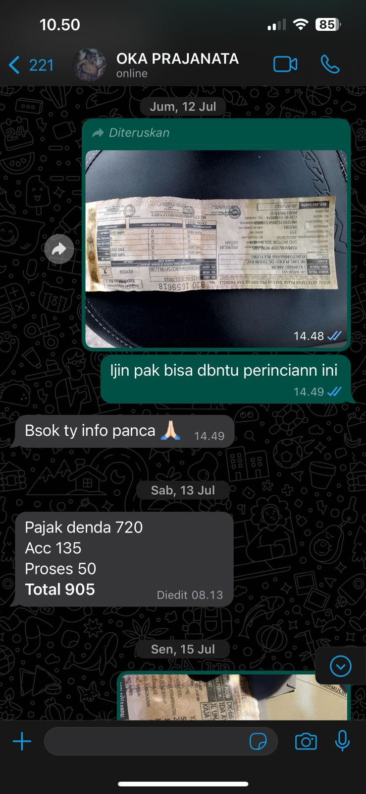SAMSAT NMAX

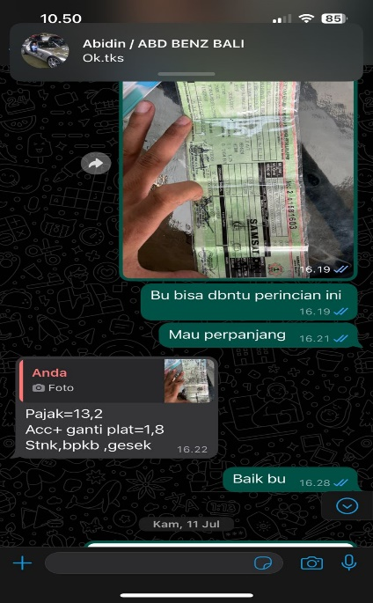

1. SAMSAT RUBICON (WAIT)
2. CAT VELG GLA (NOTA DI AMPLOP)
3. 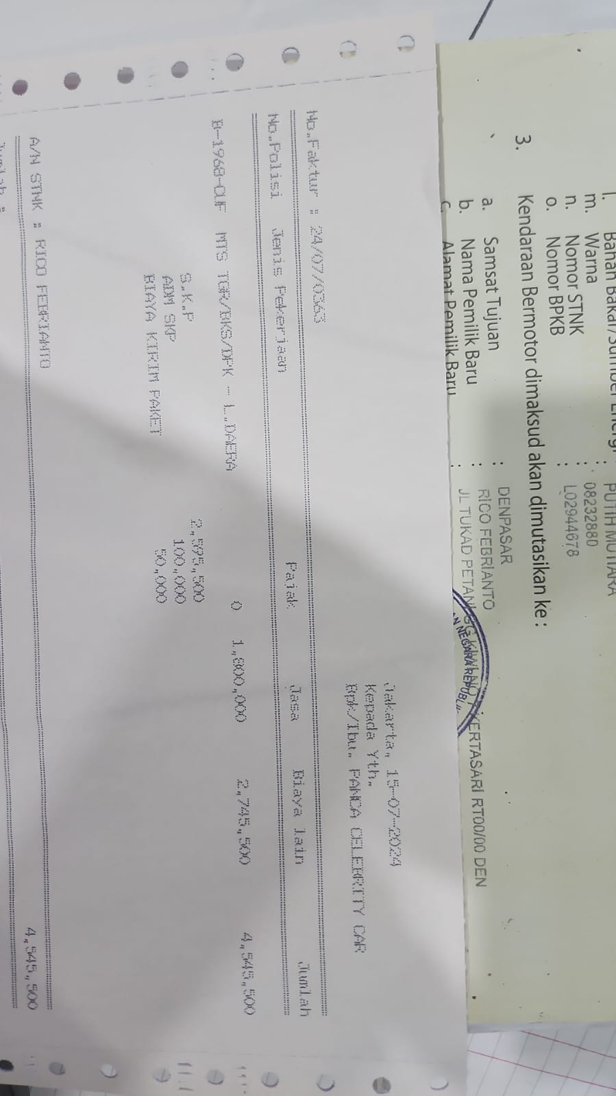CABUT BERKAS MIRAGE
4. 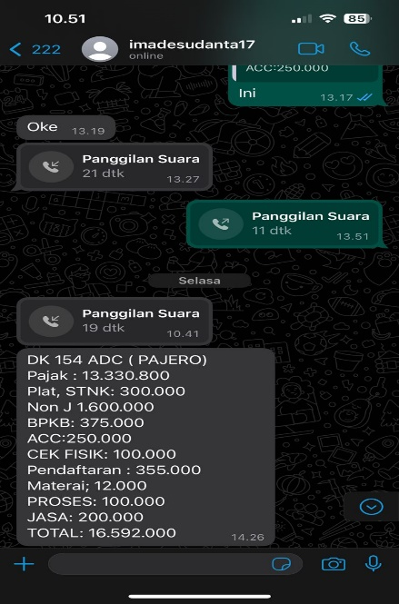BBN PAJERO
5. 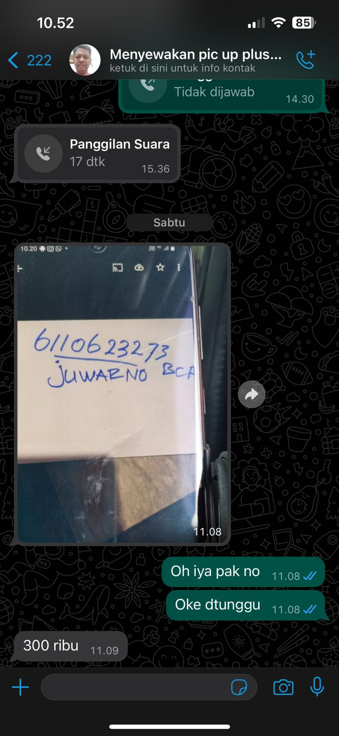PICKUP MIDROLIK
6. 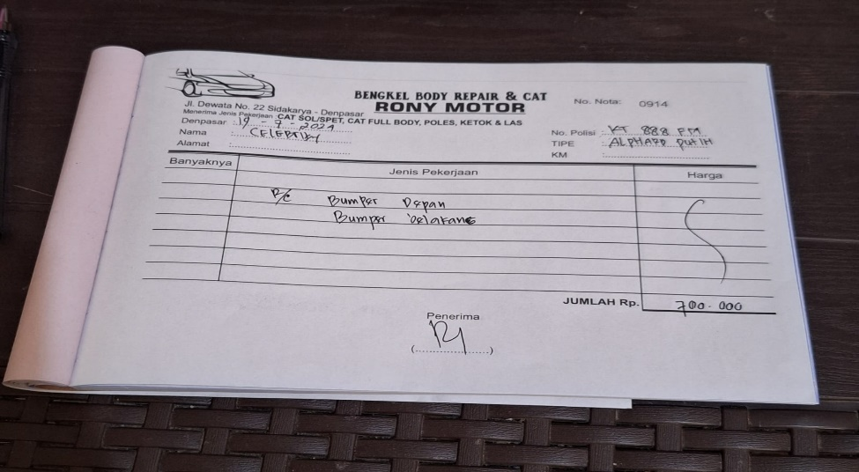CAT ALPHARD KT 888 FM
7. CAT GLA PUTIH DK 1238 FBX

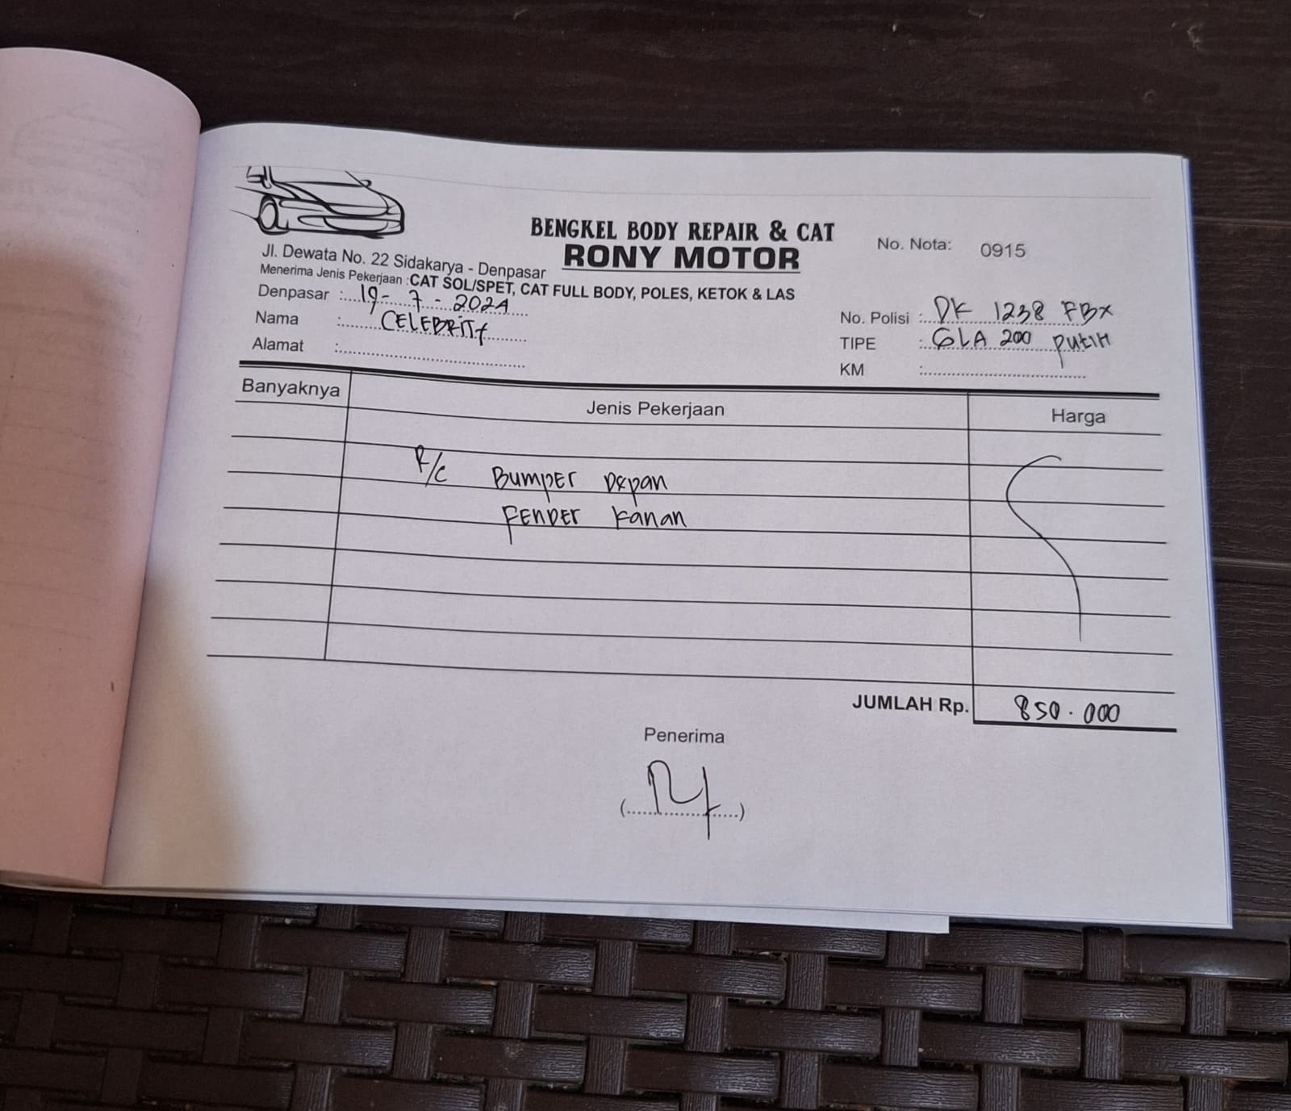

1. 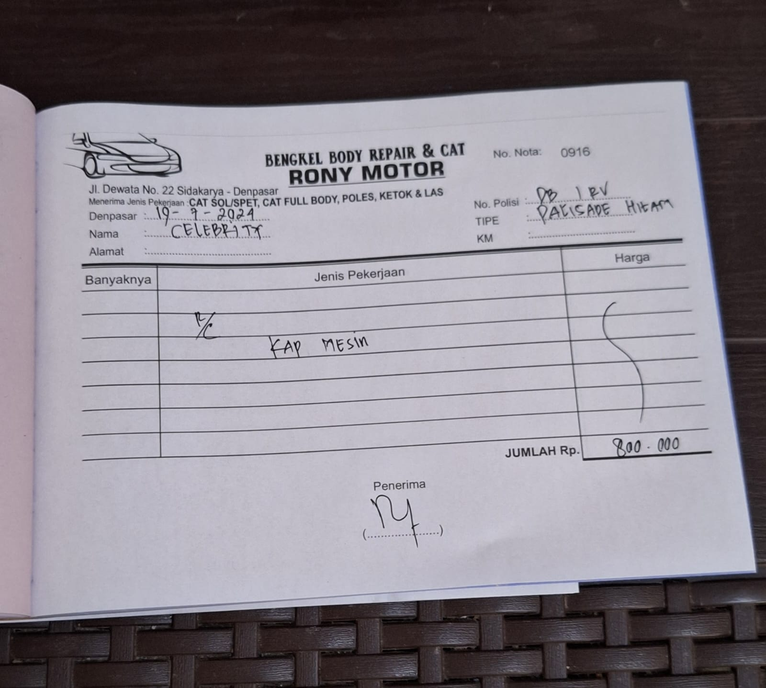CAT PALISADE DB 1 RV